Hands on React - Day 3

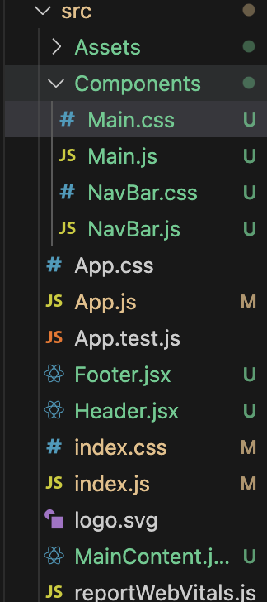

components

main.css

.main{

padding-top: 50px;

padding-left: 30px;

}

.list{

padding-top:20px;

padding-left: 30px;

}

ul li::marker {

color: #61dbfb;

}

main.js

import "./Main.css"

export default function Main(){

return (

<div className="main">

<h1 className="heading">Fun facts about React</h1>

<ul className="list">

<li>Was first released in 2013</li><br></br>

<li>Was originally created by Jordan Walke</li><br></br>

<li>Has well over 100K stars on GitHub</li><br></br>

<li>Is maintained by Meta</li><br></br>

<li>Powers thousands of enterprise apps, including mobile apps</li>

</ul>

</div>

)

}

navbar.css

.nav{

display: flex;

align-items: center;

justify-content: left;

background: #1e1f21;

padding: 20px ;

}

.img{

width: 80px;

height: 80px;

}

.text{

padding-left: 10px;

color: #61dbfb;

}

navbar.js

import Logo from "../Assets/logo192.png";

import "./NavBar.css"

export default function NavBar() {

return (

<div className="nav">

<img src={Logo} alt="App Logo" className="img"/>

<h1 className="text">ReactFacts</h1>

</div>

);

}

app.js

import Main from "./Components/Main";

import NavBar from "./Components/NavBar";

export default function App(){

return (

<>

<NavBar></NavBar>

<Main></Main>

</>

)

}

index.css

body {

margin: 0;

font-family: Arial, Helvetica, sans-serif;

background: #27292c;

color: aliceblue;

overflow-x: hidden;

}

.page-container {

min-height: 100vh;

padding: 20px;

border: 5px solid aliceblue;

box-sizing: border-box;

}

\* {

margin: 0;

padding: 0;

box-sizing: border-box;

}

html, body {

height: 100%;

width: 100%;

}

index.js

import { createRoot } from "react-dom/client";

import App from "./App";

import './index.css';

const root = createRoot(document.getElementById('root'));

root.render(

<App></App>

)